IP-BENEFITS: business targets that could be reached using ip-tools

# | BUSINESS TARGET | DECRIPTION
 | BRAND PROTECTION | Legal protection of corporate or product brand
 | INVESTMENTS & LOANS ATTRACTION | Receiving bank loans and investments using valued IP-assets as a mortgage.  Attracting an investor, selling a business, preparation for presentation to investors
 | PRESTIGIOUS STATUS & BUSINESS VALUATION | Increasing the authorized capital, registered in founding documents (charter, bylaws).  Use of IP to increase the market value of business to prove a serious partner status, valuation of IP-assets
 | ANTI TAKE-OVER | Full protection of business from unfair competitors, third party rightsholders (patent, copyright or know-how owners) former employees, unethical officials from state bodies.
 | BUSINESS REPUTATION | Prohibition of slander, prevention of discrediting business reputation  Compensation for damage to business reputation as a result of unfair competition, fraud and provocations among clients and consumers.
 | COSTS  CAPITALIZATION | Capitalization of marketing, salaries, PR, consulting expenses to increase value on intangible assets
 | CUSTOMER LIST AND SUPPLIERS DATABASE  PROTECTION | Protection of the clients and suppliers databases from unauthorized using
 | INTERNATIONAL BUSINESS | Establishment of an international business with basic protection of its rights in the countries of operations / services
 | ANTI-PLAGIARISM | Prevention and prohibition of illegal using of IP
 | IMPORT AND EXPORT | Control of Import and Export operations with goods/products
 | LICENSING & FRANCHISING | Scaling of current business under licenses and franchises
 | IP-AUDIT | Study of all types of risks for business.
 | SMART-INHERITANCE | Effective legal system of business transfer to successors (heirs).  Creating an optimal scheme for the transfer of IP to inheritors
 | SMART-DIVORCE | Saving business assets during divorce process
 | CROWD-FUNDING  IPO, ICO, IPS | Using IP-tools for exit on IPO, ICO (blockchain), IPS (Intellectual Property Sharing)
 | SUBSIDIARIES NETWORK | Using IP to create affiliate structures, daughter enterprises
 | ANTI-COUNTERFEIT | Blocking advertising, sales and confiscation of illegal copies of goods
 | SMART-HR | Creation an innovative motivation system of key employees using IP-tools
 | DIGITAL AND SOCIAL MEDIA ASSETS | Legal protection of social media accounts as an IP-assets
 | MARKET MONOPOLIZATION | Monopolization of the market segment/niche
 | IP-SCANNER: PENALTY FREE BUSINESS PROCESS | Avoiding of government fines for the non-proper recording and use and recording of IP in company documents and financial reporting  SOURCES OF RISKS  Official bodies Unfair competitors Former employees  BASIC AED 1,500 Dubai Economic Department Dubai Municipality Corporate brand (s) Product brand (s) Packages, services, etc. Customer list Marketing materials Sales tools  STANDARD AED 5,000 All in BASIC plus:  Dubai police FTA Public Prosecution Web-site Social Media Accounts Technologies Suppliers list In-house databases  VIP AED 10,000 All in STANDARD plus:  National Security Cyber Crimes Dept Ministry of Finance Mob apps Market share (segment) Strategic clients/contracts Partners network Digital assets Key employees
 | BRANDING STRATEGY | Creation of short and long-term branding, positioning, marketing Strategy with Action-plan.
 | IP-STRATEGY | IP-Strategy is a high-level action plan of a company to achieve ambitious business goals under conditions of market uncertainty with most profitable and effective use of intellectual property assets  3 reasons - IP-Strategy helps:  1. To identify existing (or planned to create) intangible business assets of the company/private individual, and classify to which type of intellectual property identified intangible assets are belonging;  2. To find best legal tools for IP-protection in terms of costs, time, regions/branches covering, law enforcement system;  3. Create a clear understanding how to capitalize costs for personnel, marketing, services, manufacturing to the real value of business
 | DEBTS CLEARANCE | Settlements and clearance of financial debts using IP-assets instead of money (debt clearing according to received notifications letter, claims, court decisions, etc.)
 | LOSS REDUCTION | Reduction of period costs, optimization of accounting indicators in financial statements (profit increasing, etc)
 | STARTUP | Development of a startup, an innovative project, protection of startup idea, business model
 | PARTNERS NETWORK | Certification of partners, contractors and other business agents  Creation of flexible convenient legal system for quick launch and development of cooperation with new business partners
 | ROYALTIES JUSTIFICATION | Justification of large royalties for using IP-assets (for banks, investors)
 | SOFT-LIQUIDATION | Withdrawal of money by liquidation, bankruptcy, prevention of forced liquidation
 | PROTECTION OF INVESTOR | Creation a legal system with priority protection of investor's rights and interests
 | SALES INCREASING | Using IP-tools to increase sales of goods and services
 | GOVERNMENT SUPPORT | Receiving free support of state bodies for the protection of intellectual property rights
 | MANUFACTURING LAUNCHING | Creation legal structure and system for secure launching of manufacturing in foreign countries
 | PRODUCT PROTECTION | Secure using of products, services, technologies (concept of the product)
 | MARKET MONITORING | Creation a system of control about market to identify illegal actions on unfair competitors
 | MEDIA CONTENT  PROTECTION | Legal protection of different types of media content
 | CREATION OF MONEY  GENERATING ASSETS | Changing legal system of company from expenses to profit generating model  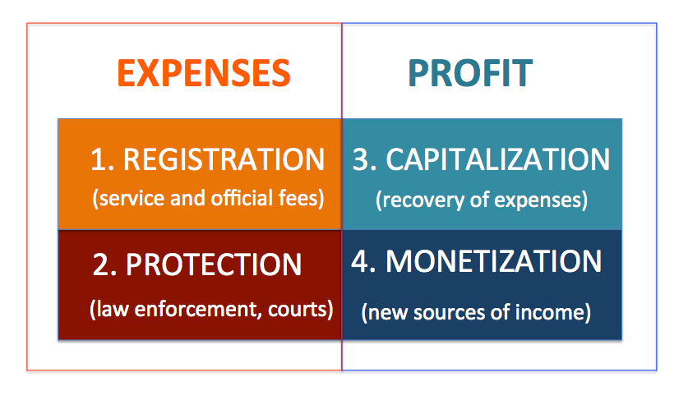
 | IP-CAPITAL  VISUAL CONTROL SYSTEM | Creation visual indicators system for business owner to control main trends and key figures  